## CS322 Network Operating Systems and Administration

## Spring I – 2022

## Midterm Exam

## This assessment is worth 35% of the total grade for this class.

## Please answer all questions below.

## This Assessment addresses the following LOs, as per the syllabus.

| **Assessment tasks** |
| --- |
|
| **A1** | **A2** | **A3** | **A4** | **A5** | **B1** | **B2** | **C1** | **C2** | **D1** |
| Midterm Exam | X | X | X |  | X | X | X | X | X | X |

## Questions 1 – 5: Theoretical background (30 points)

**Question 1:** What is the difference between a port and an IP and which are the associated protocols. How are ports and IPs employed? **(5 points)**

The Internet Protocol Address, or IP address, is a unique identifying tag for every device in a network that uses the Internet Protocol for communication. A port is a socket that receives data and is associated with a specific application. Ports are used so that incoming data can be easily accessed by the application that requires them. IP addresses are implemented at the network or internet layer, while ports are implemented at the transport layer, as part of TCP or UDP. Finally dynamic IP addresses are employed by the DHCP automatically for all devices in a network while ports are used depending on the needs of the applications.

**Question 2:** Name the different classes of network addresses and provide the respective ranges. **(5 points)**

Class A: range 0-127

Class B: range 128-191

Class C: range 192-233

For each class, "range" specifies the range of decimal values for the first byte of the network number.

**Question 3**: How many and what are the different categories of routers? **(8 points)**

Aside from wired and wireless, there are three main router categories, edge, core, and virtual. Edge routers are used to connect to outside networks like an ISP or a different organization’s network. Core routers are the backbone of a network, aiming to distribute large quantities of packets fast within the network. Virtual routers are software applications that use a computer or a server to operate like a router. Since they are not bound by physical limitations, they are fast and easy to set app while also allowing for easy scalability. Naturally, further sub-classifications and sub-categorizations exit to serve the need of every organization.

**Question 4**: Compare the two types of routing protocols and name four (4) routing metrics **(7 points)**

The two types of routing protocols are defined by their relation to an autonomous system. An autonomous system is defined as a group of networks under a single administrative control. This could include an ISP or a large cooperation. Interior Gateway Protocol, or IGP, is a routing protocol that is used to find network path information inside an Autonomous System. The most well known IGPs include RIP, IGRP, OSPF, and IS-IS. The Exterior Gateway Protocol, or EGP, is used to find network path information between Autonomous Systems. The only widely used EGB is the Border Gateway Protocol, or BGP.

When more than one path is available from a outing protocol a measurement called a metric is used to determined the optimal one. The parameters that are used to determine the metric can be:

* The number of hops.
* Bandwidth.
* Path speed.
* Packet loss.

**Question 5**: Provide a detailed description of Bandwidth, using an appropriate example as well. **(5 points)**

Bandwidth describes the theoretical number of packets that can be transmitted or received in a specific time window. Bandwidth is closely related to throughput, the average packet transfer rate; however, the two can differ greatly depending on the transmission requirements. For example, a line with 100Mbs bandwidth can at any time measure a throughout of less that 1Mbs, assuming there is no heavy network usage. That would indicate that while 100 megabits can be transferred each second by the connection, we are currently transferring only 1. The throughput can never exceed the bandwidth under normal circumstances.

## Questions 6 – 7: Networking measurements (35 points)

**Question 6**: Find the local IP of your device and the public IP of your Internet connection (if possible) **(5 points**)

Private IPv4 Address: 192.168.1.6

Private IPv6 Address: 2a02:214c:8464:6b00:459d:5cdd:3b99:9f6a

Public IPv4 Address: 79.103.15.140

Public IPv6 Address: 2a02:214c:8464:6b00:9476:edaf:da35:f6bf

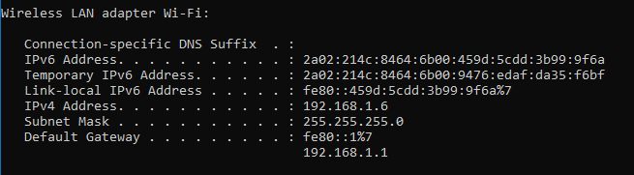

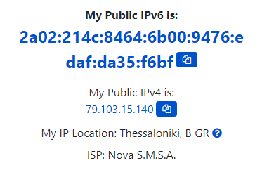

**Question 7 (30 points)**:

1. On your browser, go to [www.youtube.com](http://www.youtube.com) and start watching a high-definition video of your choice (video quality set to Auto).

2. Open wireshark and start capturing for 30 seconds while watching the video.

3. Apply the appropriate filters to keep only the video stream-associated packets.

4. Provide information on performance metrics (throughput, number of packets captured, average delay)

After finishing capturing the data, the first step is to apply the UDP filter, since video streaming utilizes this protocol. Youtube seems toy be using an alteration of the normal UDP protocol called QUIC, however after filtering for UDP, QUIC packets are also displayed.

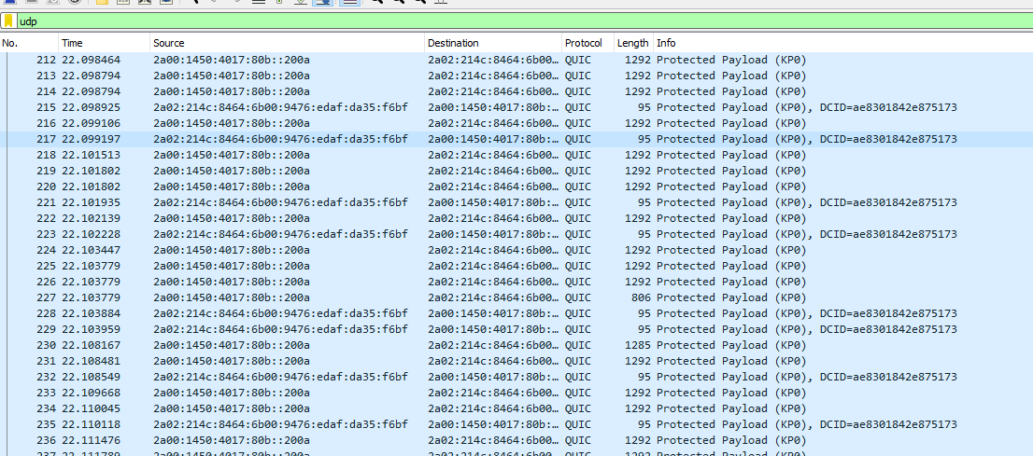

Next, we use nslookup for [www.youtube.com](http://www.youtube.com) in order to obtain the ip adresses related to the domain.

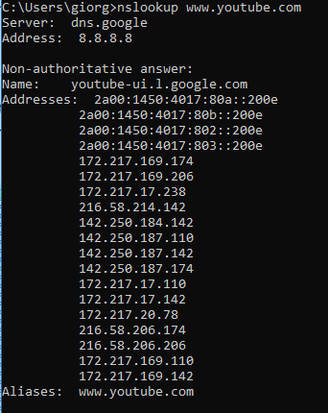

If we were in a “field” situation, we would have to use the filter ip.addr == … or ipv6.addr==… in order to test all the addresses and see which ones our connection is using; however, since in our testing we terminated all other connections, we can assume that nearly all UDP traffic is related to the video streaming and perform the analytics directly.

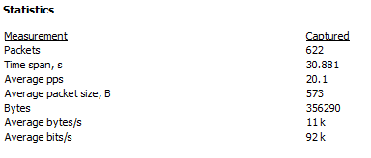

Here we can see the number of packets, the time span of the capture, the average packet/second rate, the average packet size in Bytes, the total Bytes of the capture, the average bytes/second rate, and the average bits/second rate (usually how throughput and bandwidth are measured). Below we have a graph of the throughput. Since WireShark started recording after the beginning of the video, it is possible that the spike noticed in throughput is when YouTube buffered the next chunk of the video.

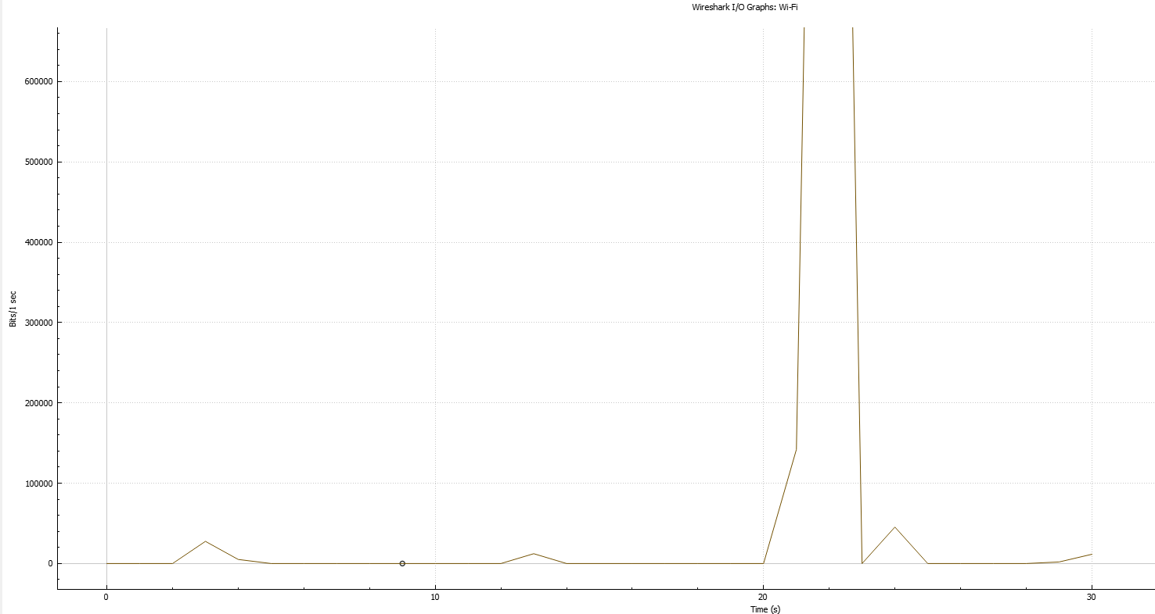

## Questions 8: Topology Simulation (35 points)

Open Cisco Packet tracer and create a network topology using one switch and five workstations. Create the connections between the Switch and the workstations, using the appropriate cables and ports.

* Assign the necessary IP addresses and subnet mask, so as to create a single subnet.
* Identify the mac addresses of the workstations, so as to ensure that everything is properly connected to the switch.
* Run the ping command between two workstations and describe in detail what happens to the messages as they traverse through the network.

To create the topology, we use a 2960 switch and 5 PCs. We connect the PCs using copper straight-through cables, using the FastEthernet0 port of each workstation and the FastEthernet0/1-5 ports on the switch. Doing so we create the following star topology.

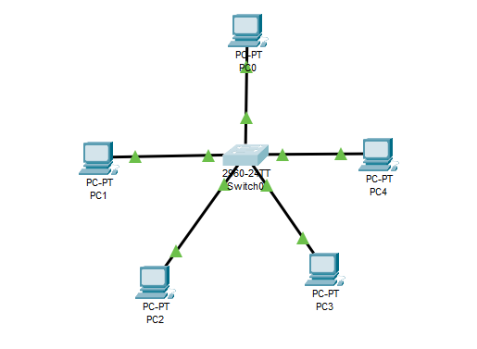

We then configure the switch by interfacing with the default vlan (vlan-1) and set the IP address 10.0.0.1 and the subnet mask 255.255.255.0.



The IP address of the switch is used as the default gateway for the substations. Since in this configuration we do not use different vlans, this could possibly be skipped. We configure the workstations, providing IP addresses from 10.0.0.2 to 10.0.0.6 and the same subnet mask as the switch.

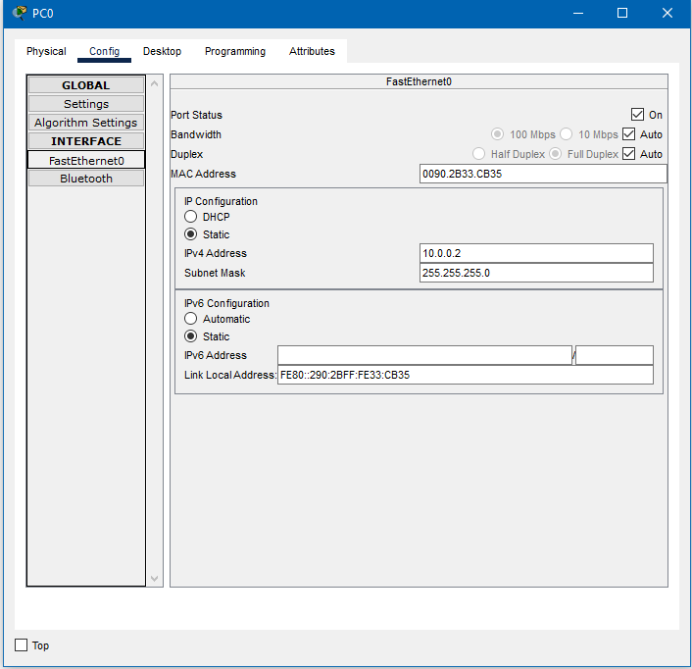

We test the connectivity by pinging PC 4 from PC 0.

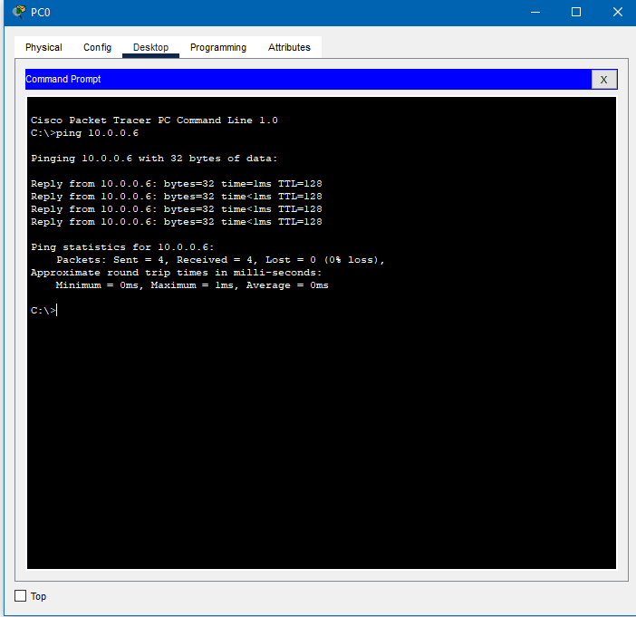

We can see that we have a connection. By using the simulation mode of the packet tracer, we can see in detail the process of pinging. We notice that first the packet is sent from PC 0 to the switch, that proceeds to relay it to every PC in the network. All PCs except PC 4 compare the recipient IP with their own and reject the packet. PC 4 responds with an echo to the switch and the mac address is noted on a CAM table on the switch’s memory, so that all subsequent transactions go directly to their destination.

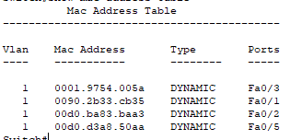

This table also includes the PCs participating in the test transaction we run prior to the simulation. Here is the complete table with all the workstations.

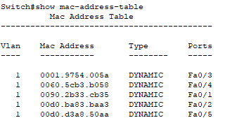

**Note:** Answers in questions 6, 7 and 8 should be accompanied, when necessary, with the appropriate screenshots.